
Front End Technologies Week 6 Coding Assignment
Points possible: 70
Category | Criteria | % of Grade
Functionality | Does the code work? | 25
Organization | Is the code clean and organized? Proper use of white space, syntax, and consistency are utilized. Names and comments are concise and clear. | 25
Creativity | Student solved the problems presented in the assignment using creativity and out of the box thinking. | 25
Completeness | All requirements of the assignment are complete. | 25

Instructions: In VS Code, or an IDE of your choice, write the code that accomplishes the objectives listed below. Ensure that the code compiles and runs as directed. Take screenshots of the code and of the running program (make sure to get screenshots of all required functionality) and paste them in this document where instructed below. Create a new repository on GitHub for this week’s assignments and push this document, with your JavaScript project code, to the repository. Add the URL for this week’s repository to this document where instructed and submit this document to your instructor when complete.
Coding Steps:
- As a team, create a full CRUD application of your choice. If you can use an existing API, use AJAX to interact with it. However, you do not have to use an API. If you do not use an API, store the entities you will create, read, update, and delete in an array.
  - Application should have at least 1 entity per team member
  - Use a form to add new entities
  - Build a way for users to update or delete entities
  - Use Bootstrap and CSS to style your project

Screenshots of Code:

I meet with Branden during office hours and he said I could submit the house code. I did change it just a bit to make it look different. I had spent lots of time this week writing code and trying to make it work on crudcrud.com with little success. I wish I knew early on just to pay for it to make it work!

This is the house code, slightly altered.
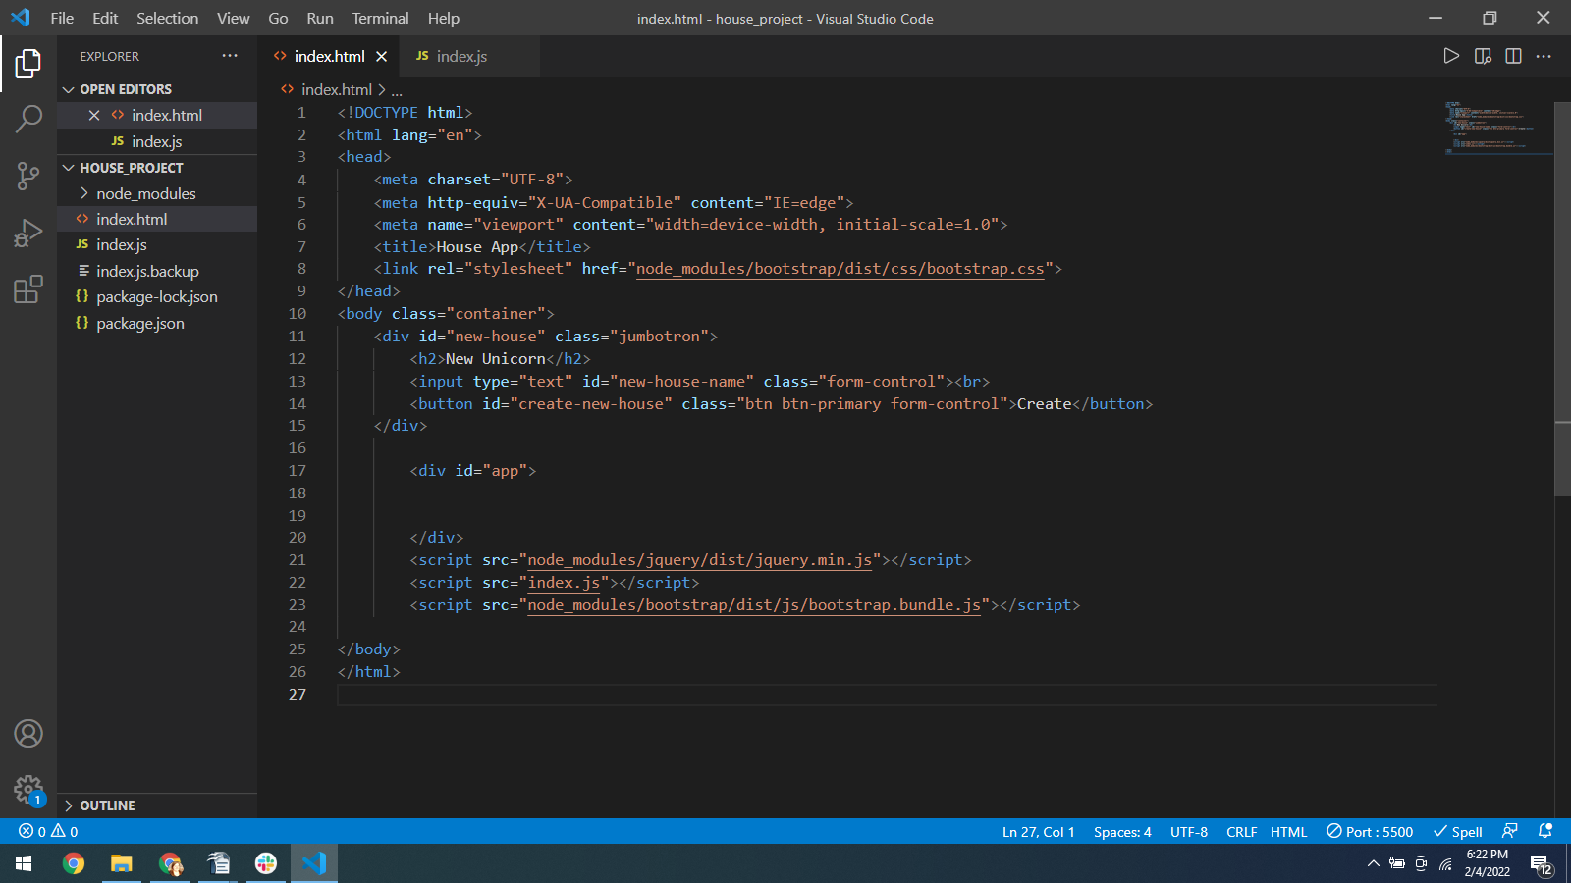
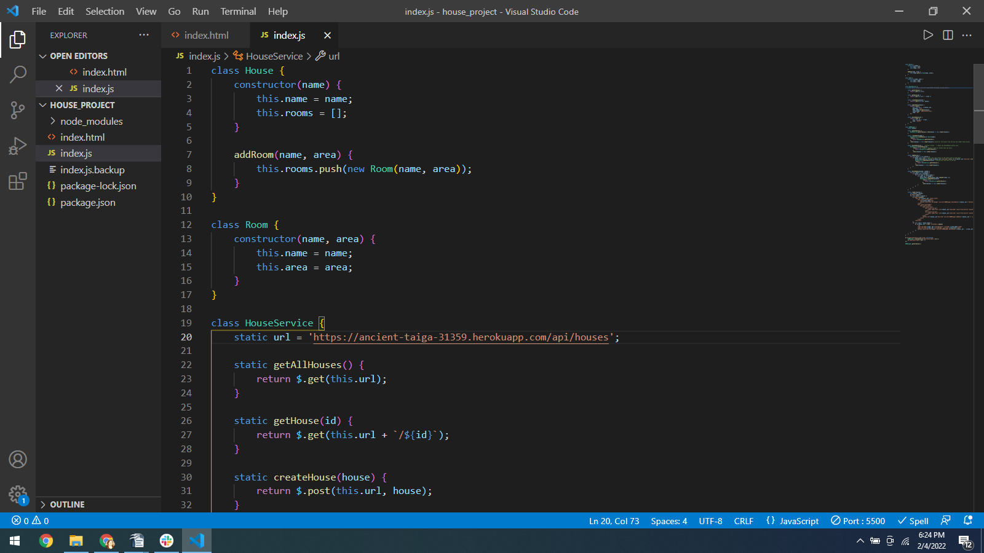
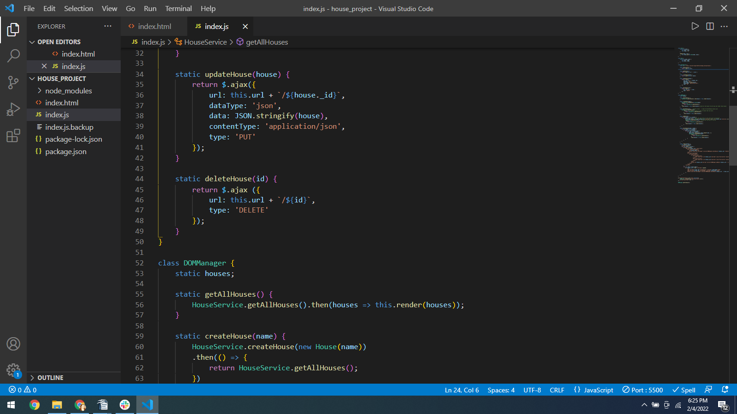
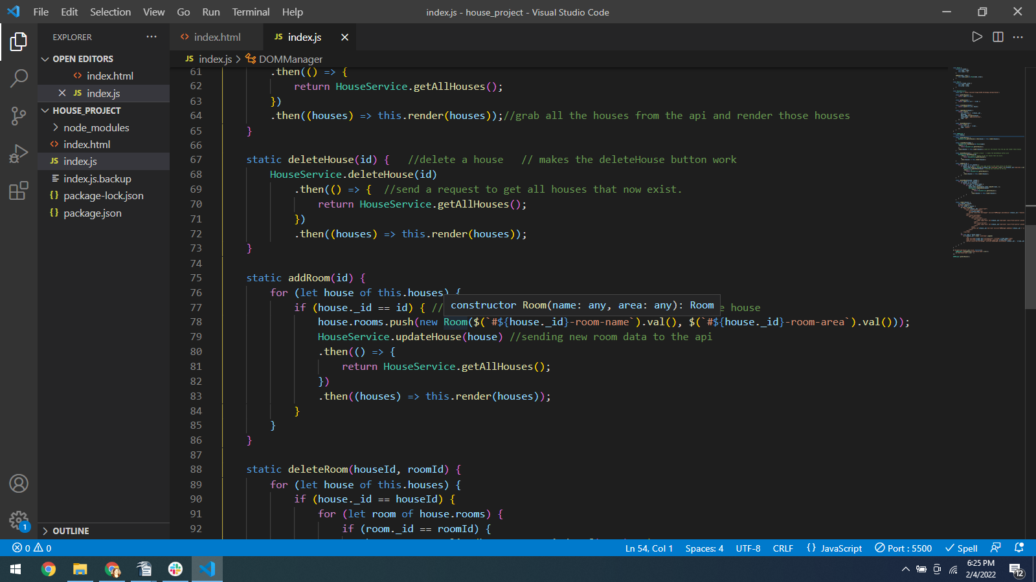

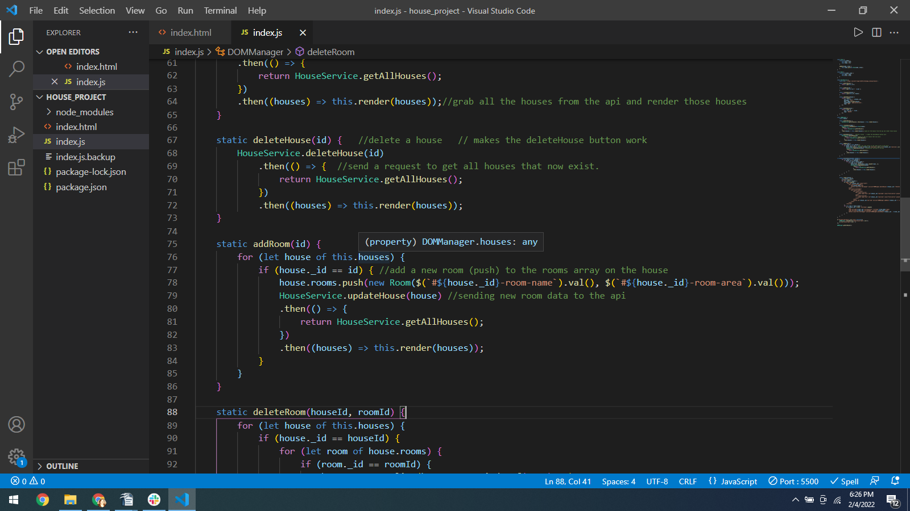
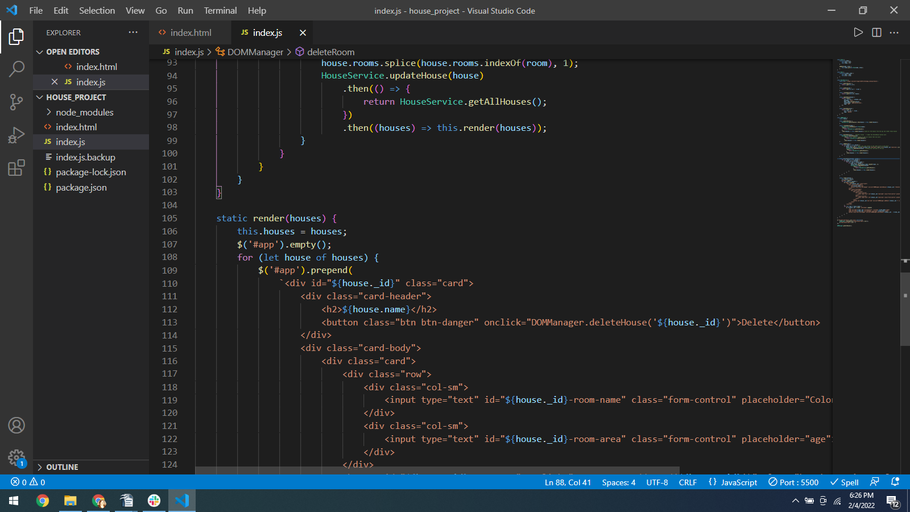

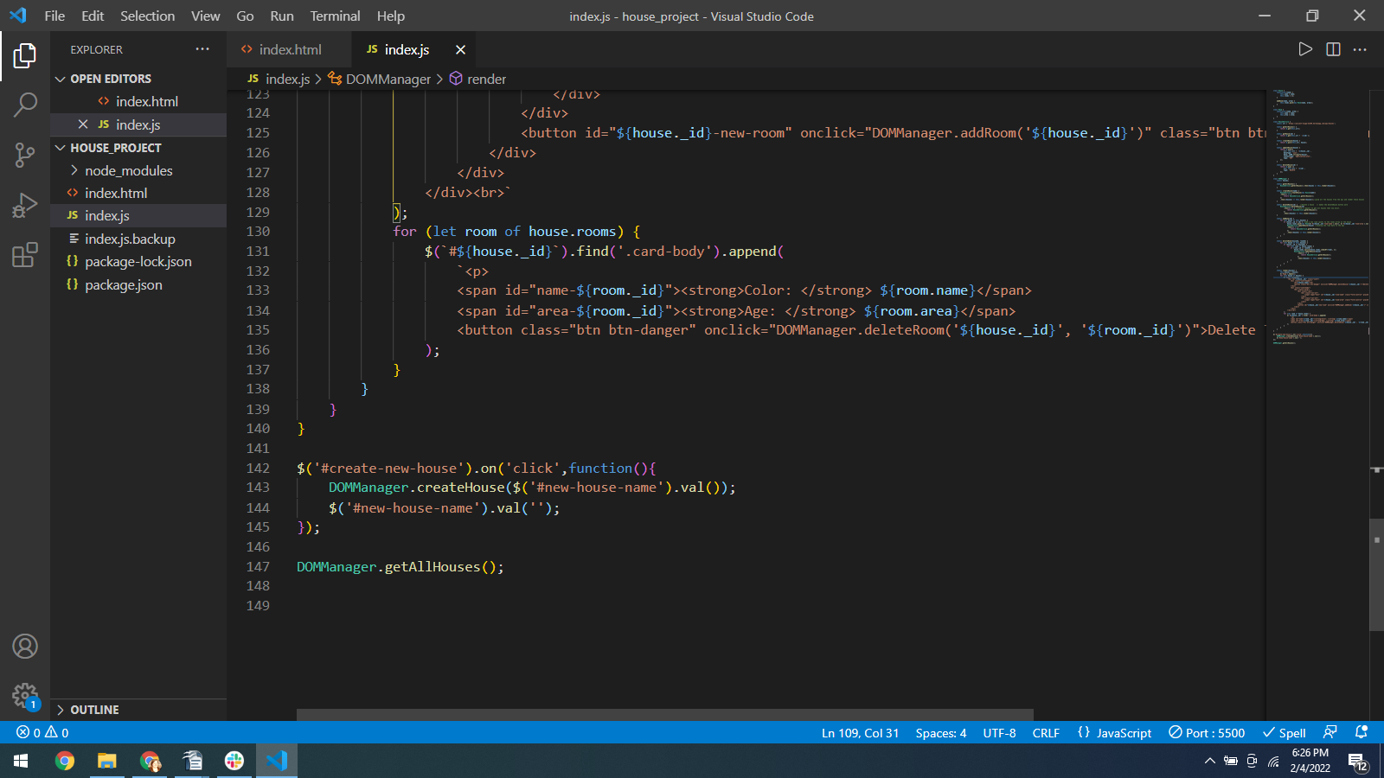

Screenshots of Running Application:
Opening screen
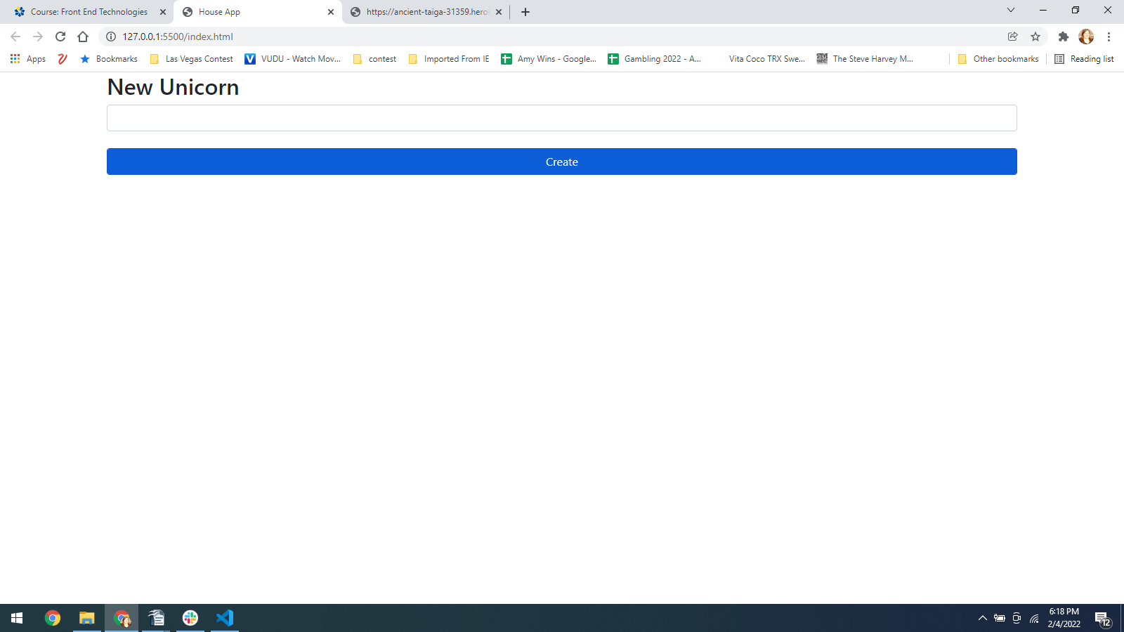
After adding unicorns and adding Traits
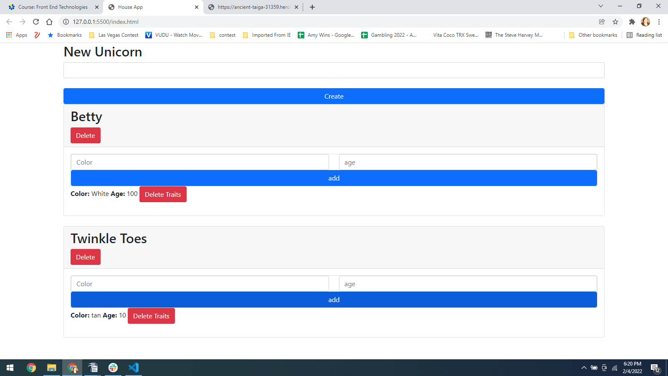

after deleting traits
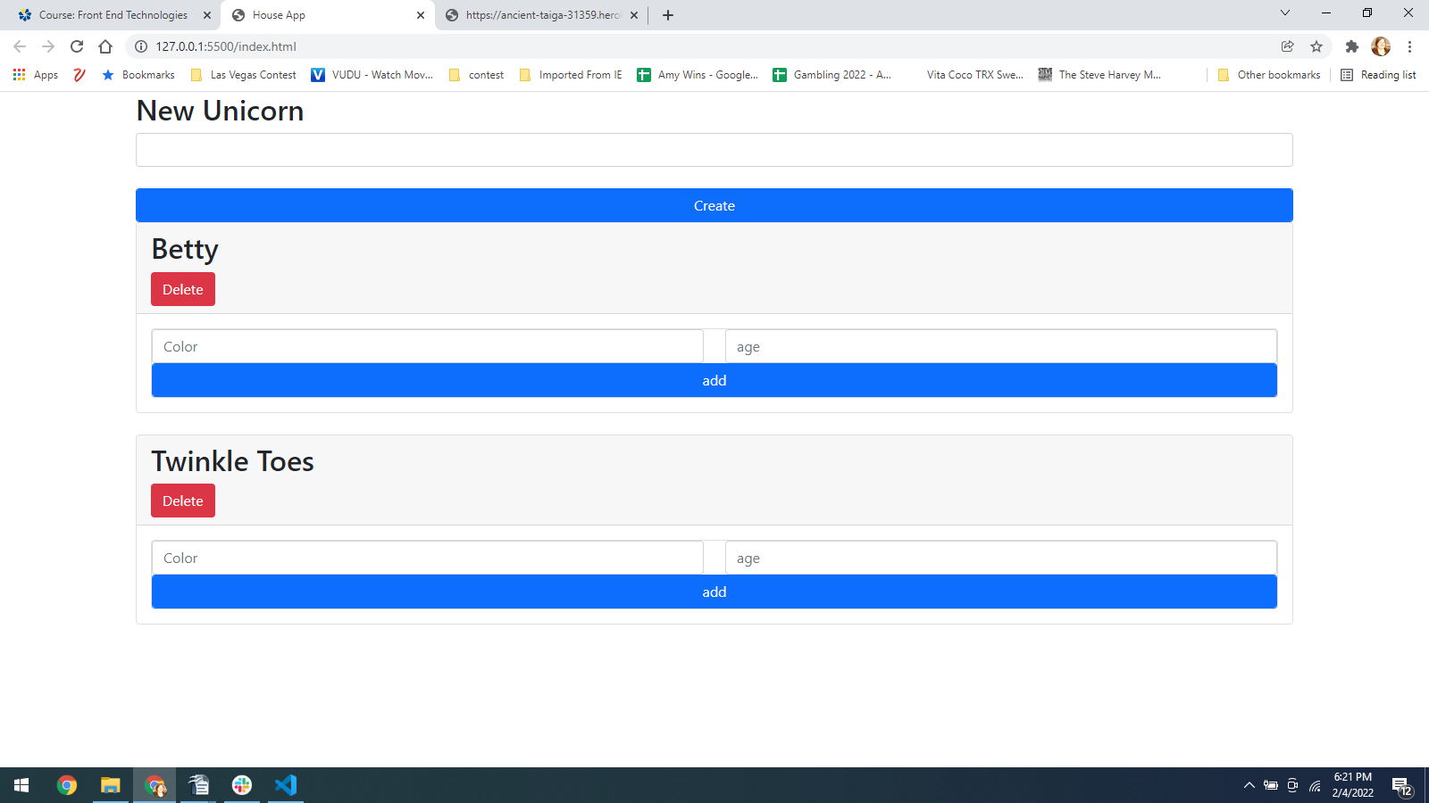
after deleting unicorns
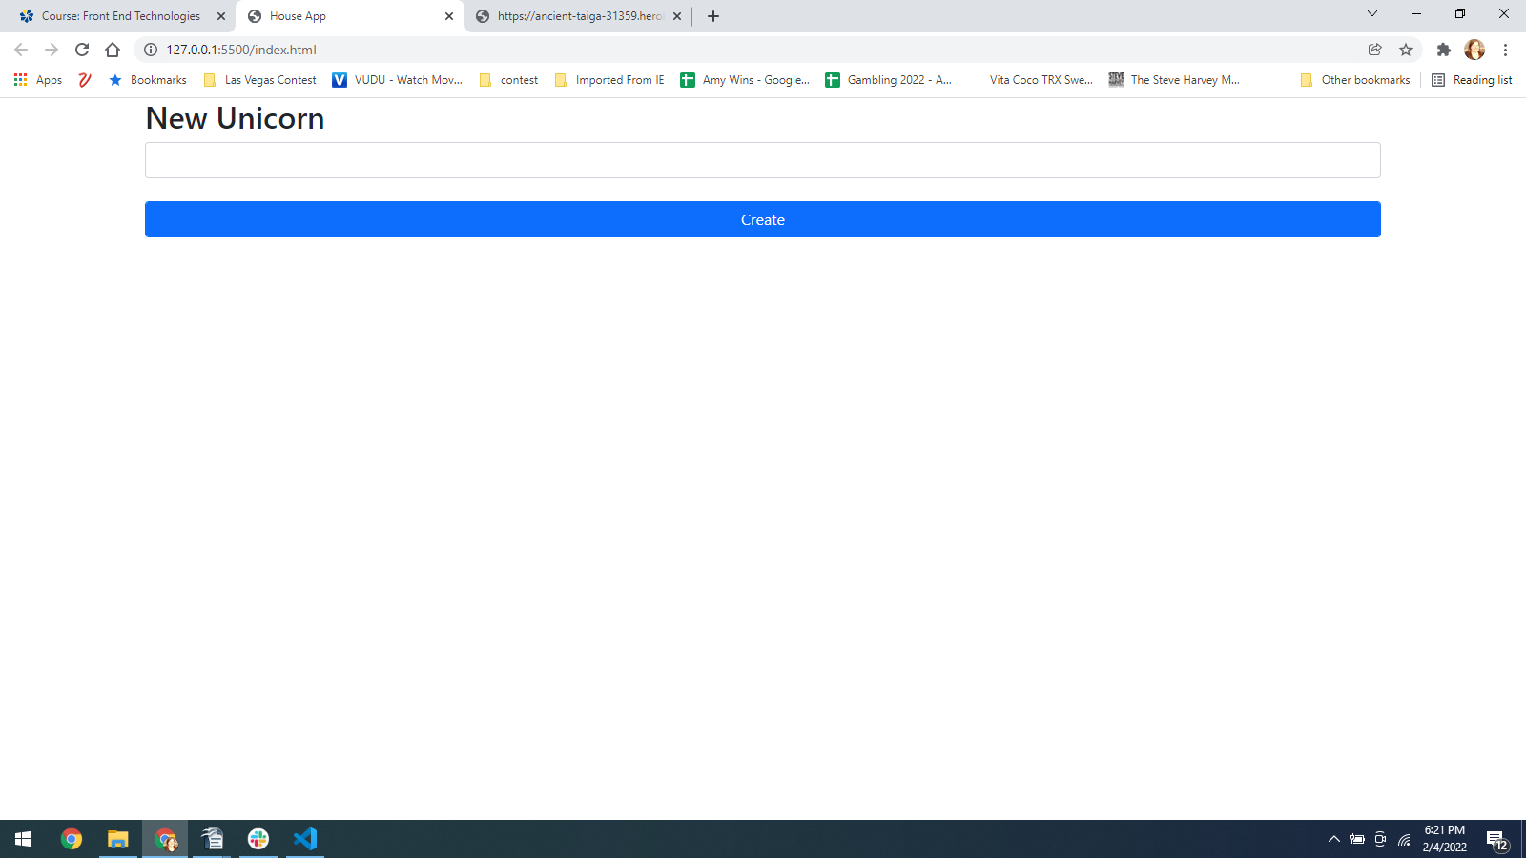
Here is the code I was trying to run on crudcrud.com
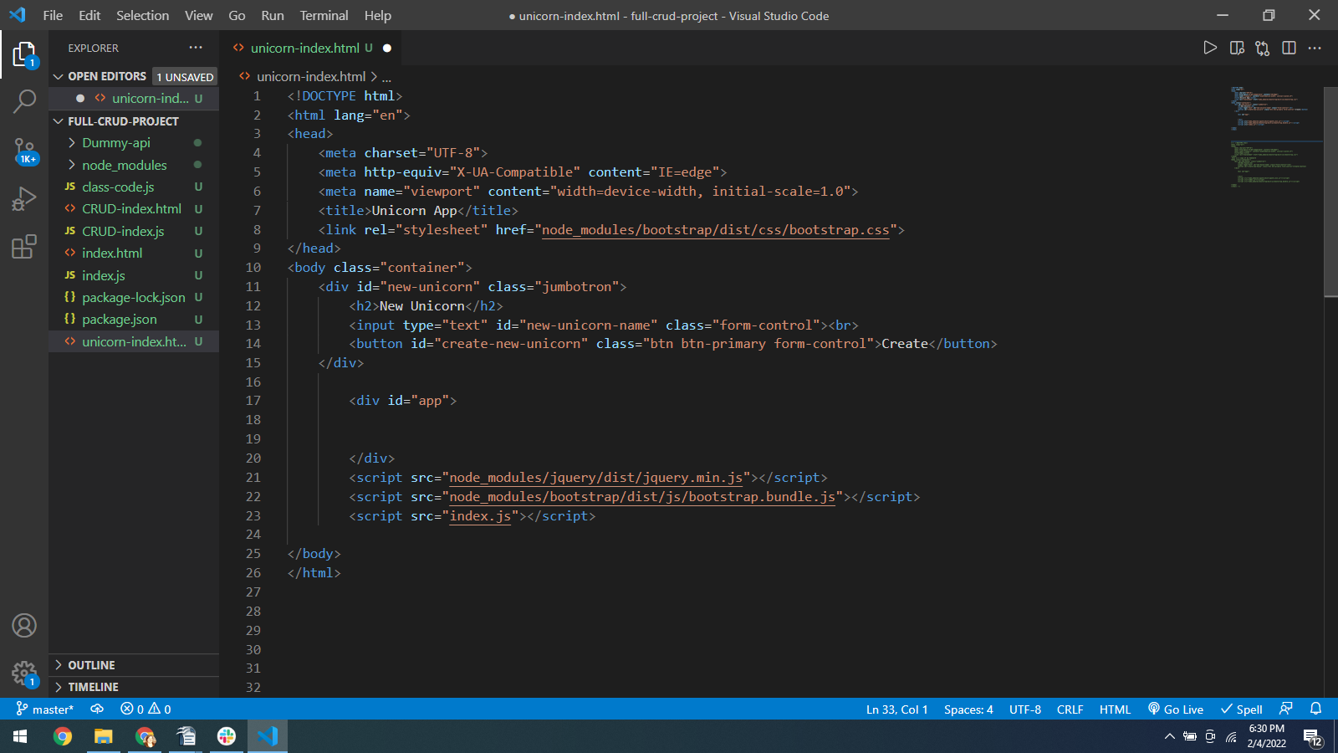
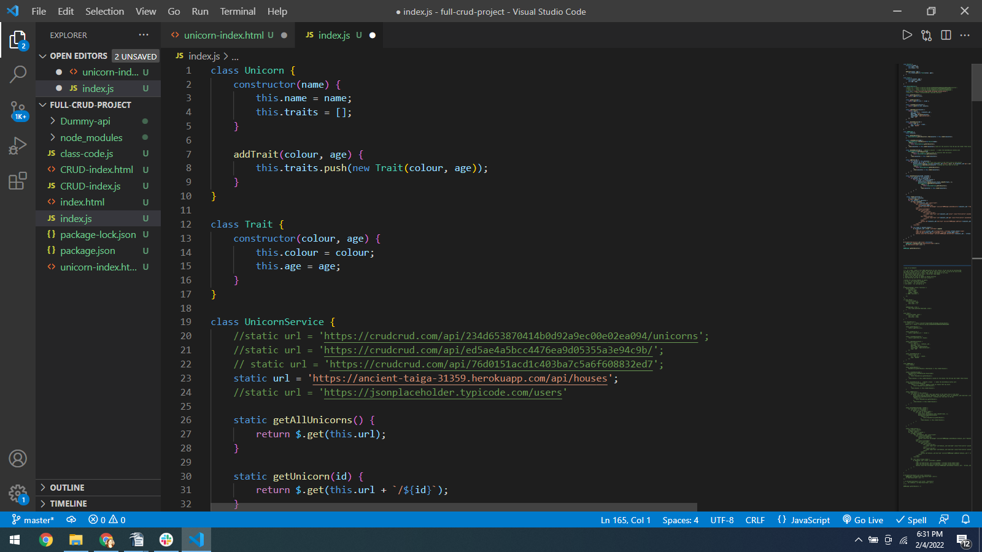
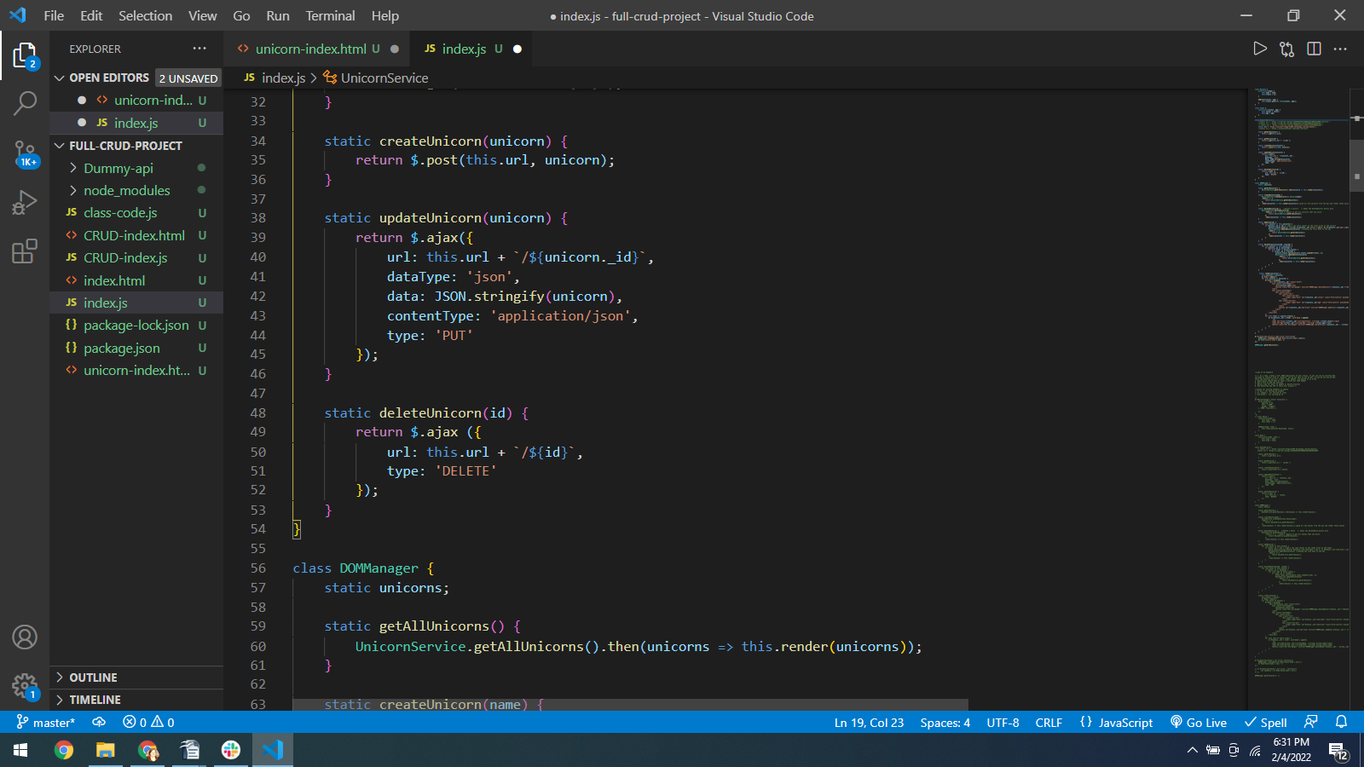

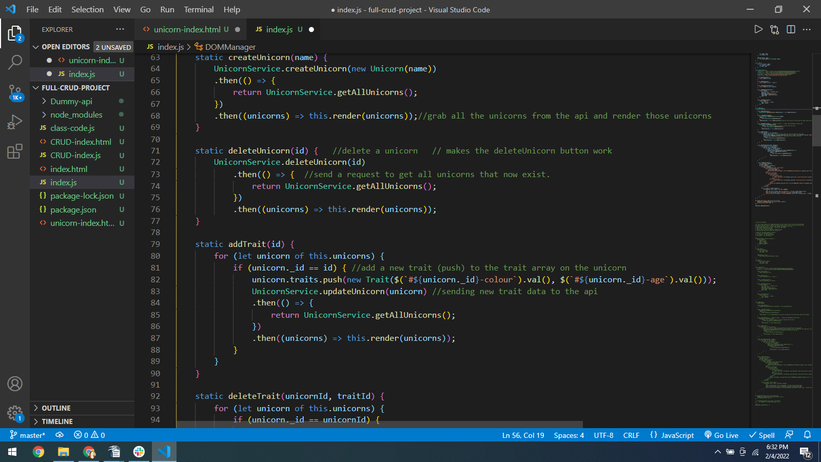
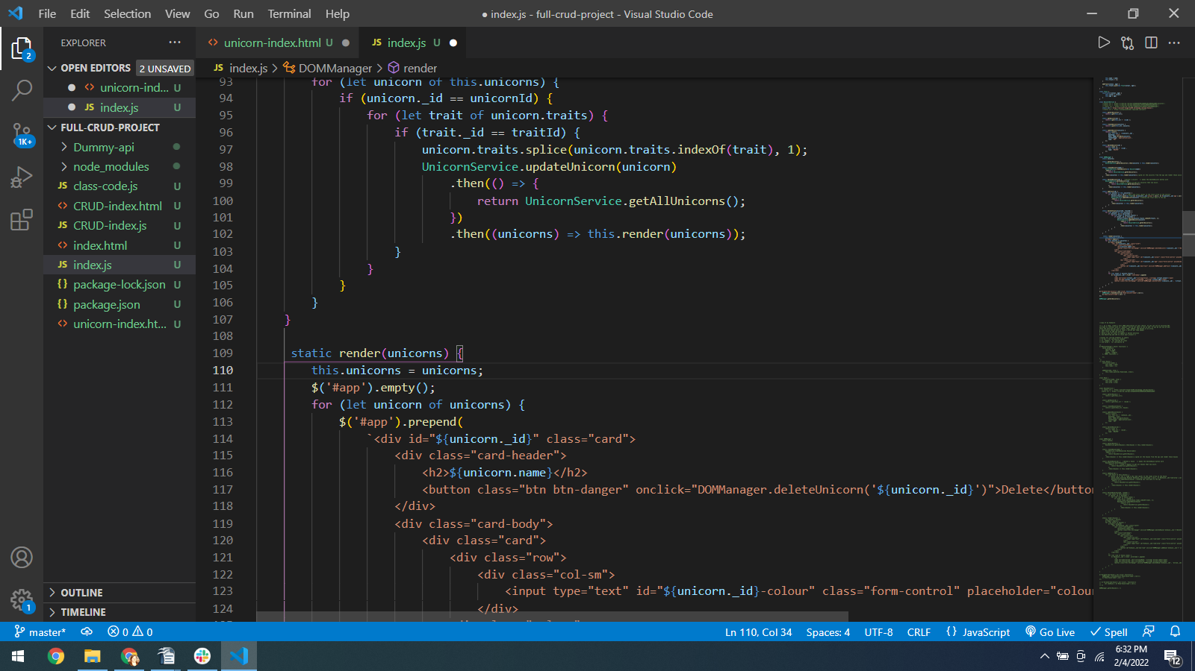

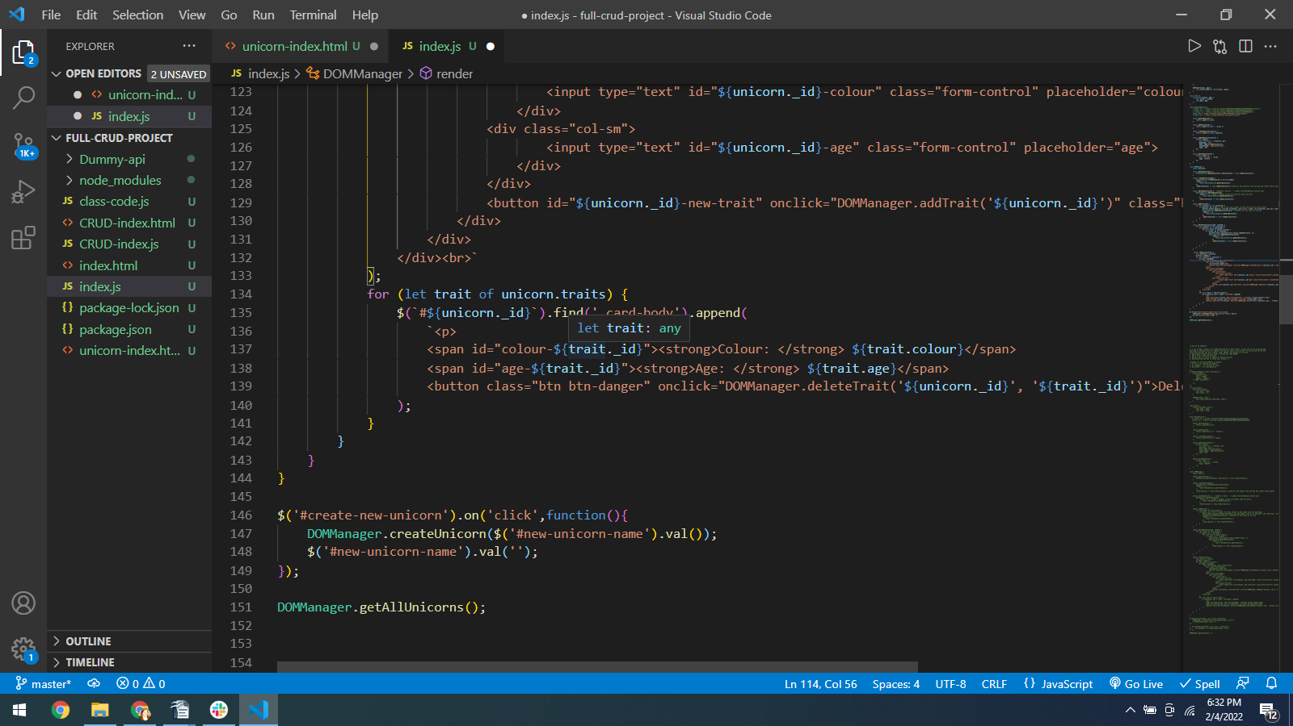

URL to GitHub Repository:
https://github.com/CodingVegas/Frontend-CRUD

